Mathematics  - Play Halves and Quarters Interactive Mad Maths game. See if you can work out how much of each shape is shaded. How quickly can you answer?  - Play the Telling the Time game. Work your way through the different levels and click on the correct time the clocks show.  - Play Hit the Button game again. Work your way through the different levels.  Year 1  - Finding half of an amount activity. Watch the videos and complete the activity sheets. (copy of sheets below)  - Finding quarter of an amount activity. Watch the video and complete the activity sheets. (copy of sheets below)  - Cut out different shapes (circles and squares work best) and try to cut them in half and in quarters. Make sure that each half is the same size – folding can help with this. Maybe if you have a pizza for dinner or a cake for pudding you can look at cutting it in halves and then quarters.  Year 2  - O’clock and half past activity. Read the information and explore the examples. Complete the activity sheets (copy of sheets below.)  - Quarter to and past activity. Explore the slide show and complete the activity sheets (copy of activity sheets below).  - Talk about times of the days when you complete different activities: getting up, having breakfast, eating lunch, eating dinner, going to bed. Maybe make your own clock and use a split pin to attach the hands and make different times of the day. | English  - Daily phonics – extra interactive games here.  - Finish working through your spelling lists on the Nazeing website.  - Try to read something every day. Whether it’s your reading book, a book from home, a comic, a magazine or even a recipe book.  - Recap over the extract from Lady Lollipop by Dick King Smith. Write an ending for the story.  - See if you can recap over the cursive handwriting style. There are examples of sheets on this link (couple below) but feel free to make up your own sheets and write some of your own words. Try and join some letters together.  - Act out the poem you created. Try to add expression when reading it – see if you can do it from memory.  Year 1  - Complete some work on alliteration here. Try to write your own sentences using alliteration – what effect does it have on your sentence?  Year 2  - Practising spelling and writing questions activity. Watch the videos and attempt the activities.
Topic  - Create a poster explaining all you have learned about ladybirds over the past few weeks. Write about the different types, where they can be found and their life-cycle. Make sure you add headings, illustrations and captions.  - Complete your collage you started last week of a ladybird. Add labels to your collage explaining parts of their body.  - PSHE – Complete the All About Me! sheet (below) about yourself. This can go to your new teacher and will tell them all about you. | Health and Wellbeing  - See if you can do some exercises every day. This week see if you can do some singing and dancing to your favourite summer songs. This video is great fun and will get you started.  - Write about your favourite things you have done/learned during lockdown. Maybe you have enjoyed spending more time with your family or maybe you’ve learned something new?  - Watch the video Lizzie and the Last Day of School here. Think about all the emotions linked to the end of the school year: the excitement of the summer holiday and the worry of starting something new.
Year 1 and 2 – Home Learning – Week 15 Monday 20th – Wednesday 22nd July Online activity Offline activity Online and offline activity
Year 1 Maths – Finding half of an amount

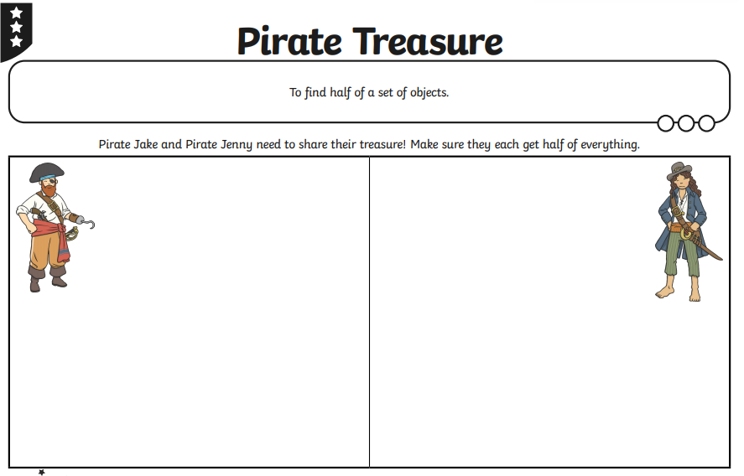

Year 1 Maths – Finding quarter of an amount

Year 2 Maths – O’clock and half past
Year 2 Maths – Quarter to and past

English – Cursive Handwriting

PSHE – All About Me!

